AI Assisted Coding
ASSIGNMENT 2.3
Name: R.S.S.GOURISHWAR
HT No: 2303A52045
Batch: 32
Question:
Task 1:
Word Frequency from Text File
Scenario: You are analyzing log files for keyword frequency.
Task: Use Gemini to generate java code that reads a text file and counts word frequency, then explains the code
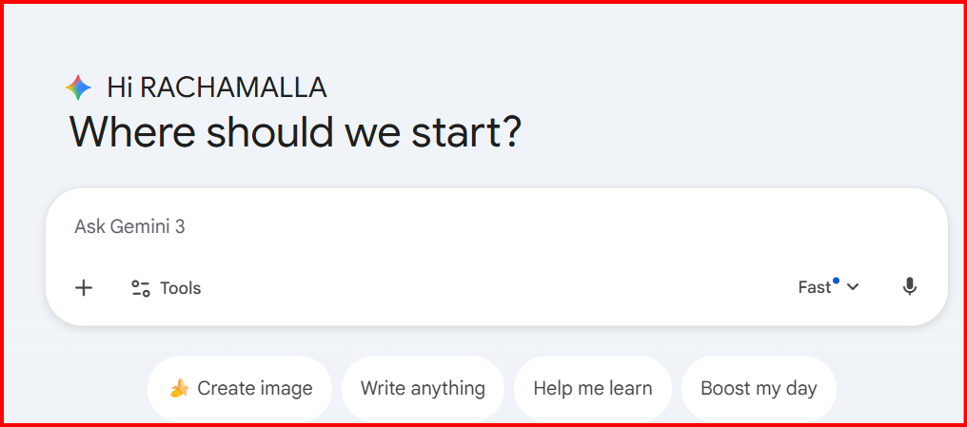

Prompt :
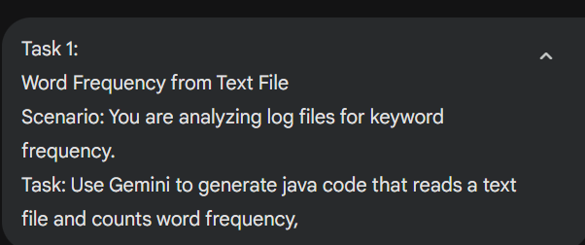
Code
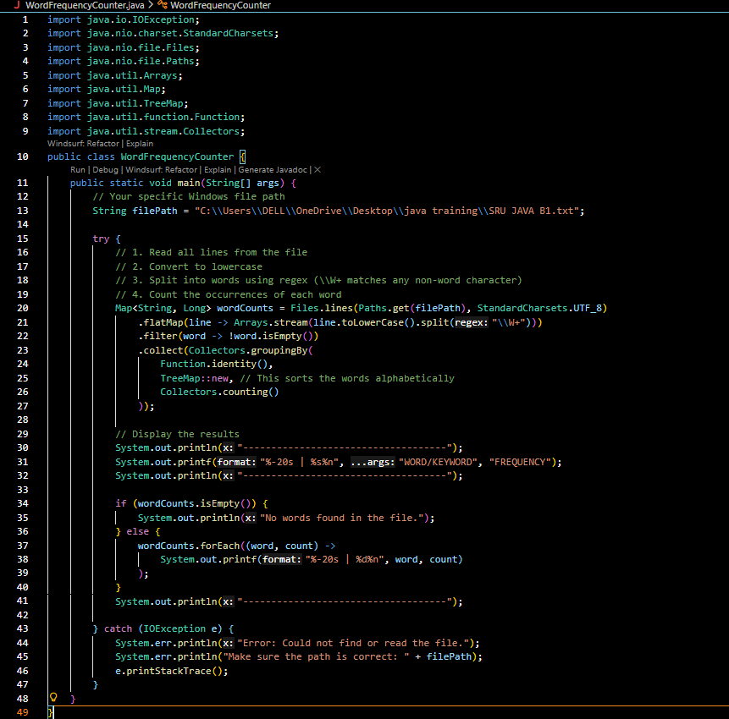
Output
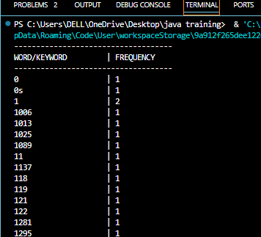
Explanation :
First, it opens your text file and reads it line by line. Then, it breaks every sentence into individual words while ignoring things like commas or periods. It turns everything into lowercase so that "Apple" and "apple" aren't counted as two different things. Each word is then tossed into a "counting bucket" (a Map) where it keeps track of how many times that word has appeared. Finally, it just prints out that bucket as an organized list for you to see.

Question:
Task 2:
File Operations Using Cursor AI
Scenario: You are automating basic file operations.
Task: Use Cursor AI to generate a program that:
Creates a text file
Writes sample text
Reads and displays the content
Prompt:

Code :
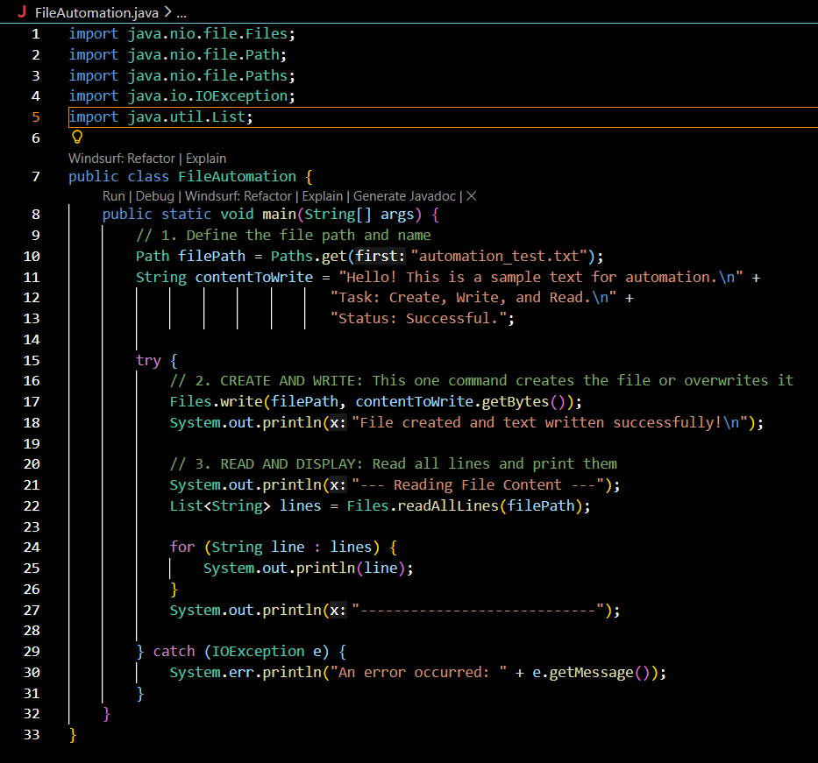
Output:
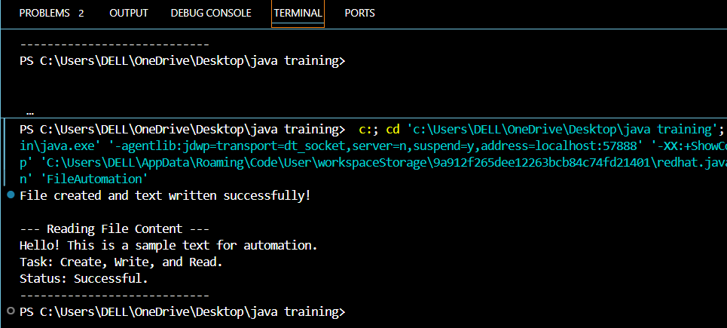
Explanation :
• Setting the Path: First, we tell Java the "address" of the file we want to work with (the filename).
• Writing the File: We use a "write" command that automatically creates the file and pours our text inside.
• Opening the File: Next, we tell Java to go back, open that same file, and grab all the lines of text.
• The Memory List: Java saves those lines into a temporary list so the computer can remember them.
• Printing: Finally, we loop through that list and print each line to the screen so we can see the result.

Question:
Task 3: CSV Data Analysis
Scenario: You are processing structured data from a CSV file.
Task: Use Gemini in Colab to read a CSV file and calculate mean, min, and max.
Prompt:
Generate java code to read a CSV file and calculate the mean, minimum, and maximum values of a numeric column.
Prompt:
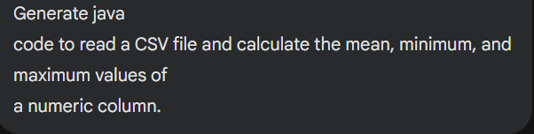
Code :
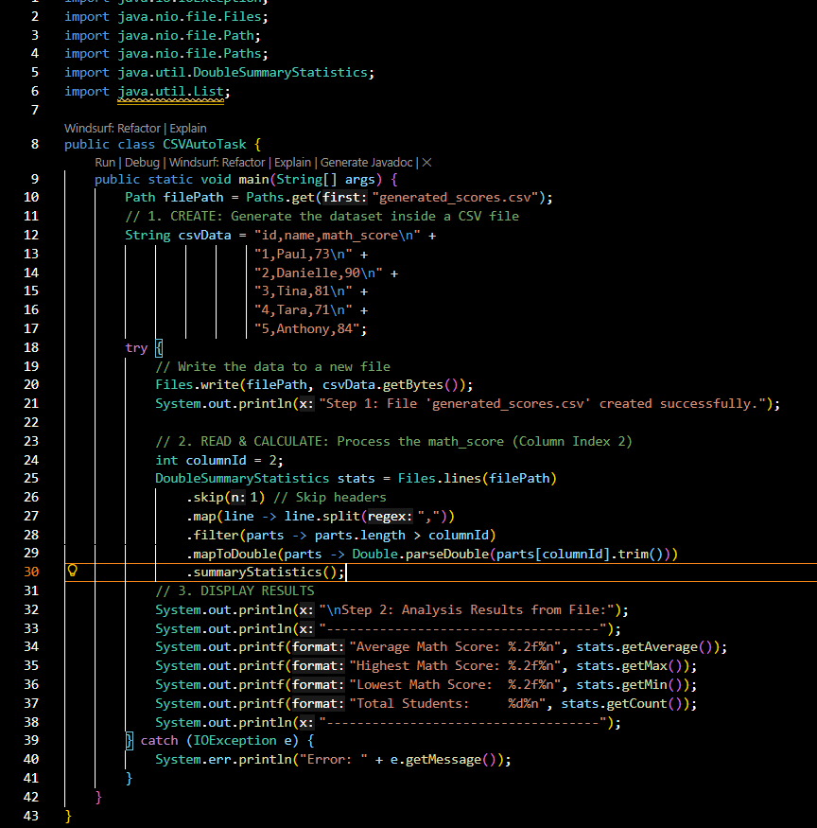
Output:
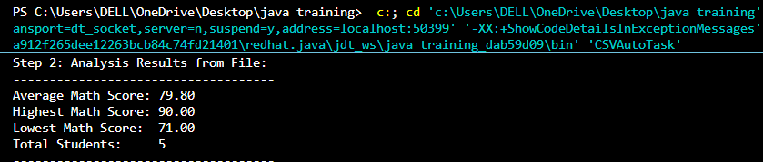
Explanation:
• Creating the File: We use Files.write to create a real file called generated_scores.csv and put our student data inside it.
• Opening to Read: After creating it, we use Files.lines to go back and open that same file so we can look at the numbers.
• The Header Skip: We skip the first line (id,name,math_score) because you can't do math on words.
• Picking the Column: We tell Java to look at Index 2 (the 3rd column), which is where our scores are stored.
• Instant Math: The summaryStatistics tool scans all the numbers we just pulled out and finds the average, highest, and lowest scores for us.

Question:
Task 4: Sorting Lists Manual vs Built-in
Scenario: You are reviewing algorithm choices for efficiency.
Task: Use Gemini to generate:
Bubble sort
Python’s built-in sort()
Compare both implementations
Prompt:

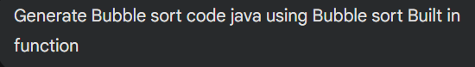

Code :
- Using nested loops Bubble sort
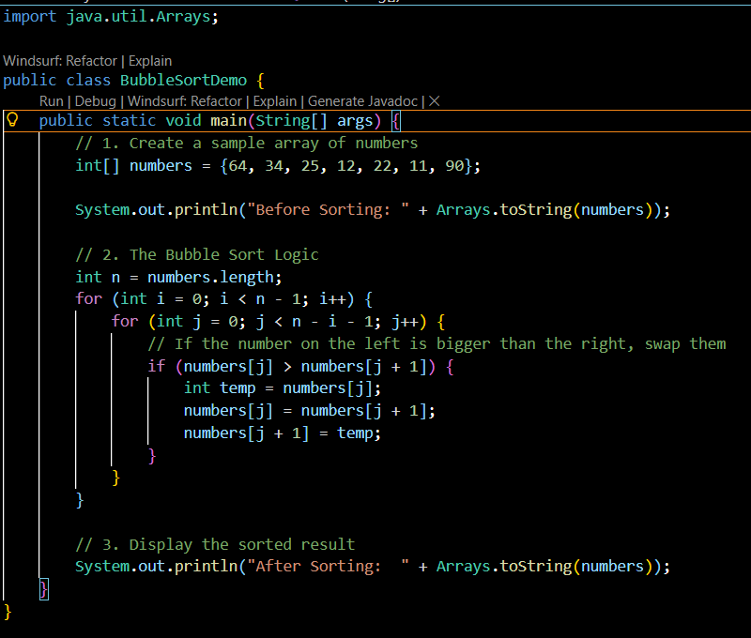
- Actually, Java does not have a specific "built-in function" named bubbleSort(). However, Java provides a very powerful built-in tool called Arrays.sort().
The Java "Built-in" Way
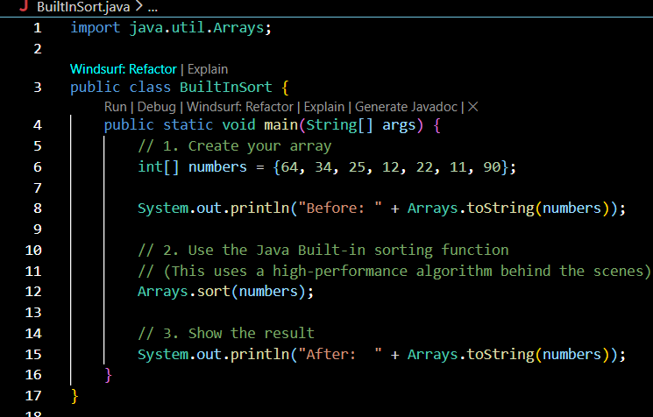
Output:
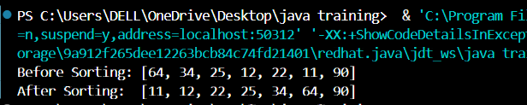

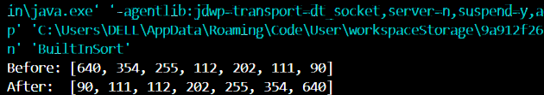

Explanation :
Bubble sort is a simple sorting algorithm that repeatedly compares and swaps adjacent elements. It is easy to understand but inefficient for large data sets.
Java sbuilt-in sort function is shorter, optimized and much faster. The built-in method should be preferred in real-world applications

